INTEGRATIVE COURSE IN PSYCHOLOGY (ICOPSYCH)

ANALYSIS ON THE RESULT OF PRE-TEST EXAMINATION IN DEVELOPMENTAL PSYCHOLOGY
MARCH 28, 2025

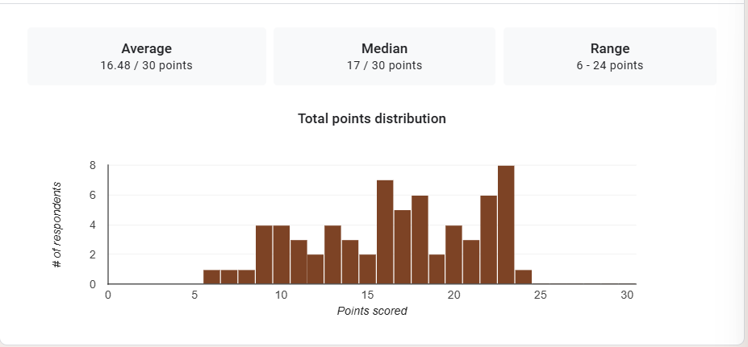

1. Mean Score: The mean score of 16.48 out of 30 suggests that, on average, participants scored just below the midpoint of the total possible score. This indicates that the overall performance of the group is relatively modest, with a tendency towards lower scores overall.

2. Median Score: The median score of 17 out of 30 is very close to the mean, suggesting that the scores are fairly evenly distributed around the middle. Since the median represents the middle score, with half of participants scoring above 17 and half below, it reinforces the idea that most participants scored around the middle of the scale.

3. Range: The range from 6 to 24 points indicates that there is some variability in the scores, but the lowest score (6) is notably low, which could indicate that some participants struggled significantly. However, the highest score (24) is still somewhat close to the upper end of the scoring scale, suggesting that there were a few higher-performing individuals.

Interpretation Summary:

-The participants, on average, scored slightly below the midpoint, with a mean score of 16.48 out of 30, indicating relatively average or modest performance overall.
-The median score of 17 suggests a fairly balanced distribution of scores, with about half of the participants scoring higher and half scoring lower.
-There is noticeable variability in the scores, with a range of 6 to 24 points, showing that while most participants performed at a moderate level, there were a few who performed significantly worse, but also some who performed better.

-Overall, the results suggest that there may be room for improvement for the majority of participants, as the mean and median scores are close to the lower half of the scale.

RATIONALIZATION:

DIFFICULT QUESTIONS:

